**Types:**

- Different ways to store data in Python (int, float, list, dict, str)  
- Can check what type something is by using the *type()* function  
- a ***class***is a template for a data type – used to define the kinds of information that class will hold and how a programmer will interact with that data  
- Capitalize the names of classes to make them easier to identify  
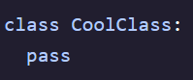

- A class must be *instantiated* before it can be used – this means an instance of the class needs to be created  
- A ***class***is *instantiated* by calling it like a function – can store to a variable to access later in program  
 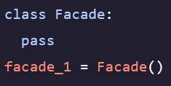

**Object Oriented Programming (OOP)**

- The pattern of defining classes and creating objects to represent the responsibilities of a program  
- Encourages sculpting entities with properties and methods names in classes to create applications  
- Instantiation takes a class and turns it into object  
- Classes that have been instantiated in code become objects that can interact with one another to perform the desired functions of the application   
- When calling *type()* on an object it returns the class of that object   
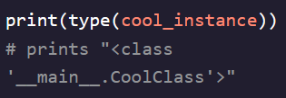

- ***_main_*** indicates that this is the current running file

**Class Variables**

- Employed when we want the same data to be available to every instance of a class  
- Defined by including it in the indented part of your class definition  
- Can access and see all of an object’s class variables by using the *object.variable* syntax  
- Classes are referenced with dot notation (*.title*) to show that they belong to a class  
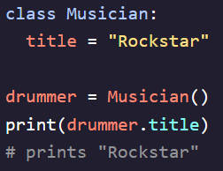 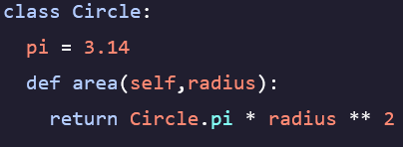

Class variables are the variables stored in the ***class*** template   
- notated as *.pi  
- Can be accessed as an attribute of the class*  
(dog_time_dilation, kms_in_a_mile)

**Methods**

- Functions that are defines as part of a class  
- The first argument in a method is always the object that is calling the method – named *self*- Methods need at least this one function and are defined just like functions except within a ***class***  
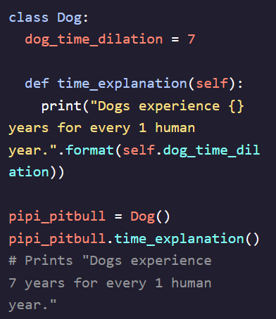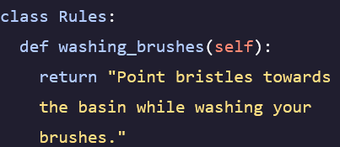

Methods are the functions stored in classes|  
- notated as *.area()* method  
(time_explanation, how_many_kms)

- Methods can take other arguments besides just self  
